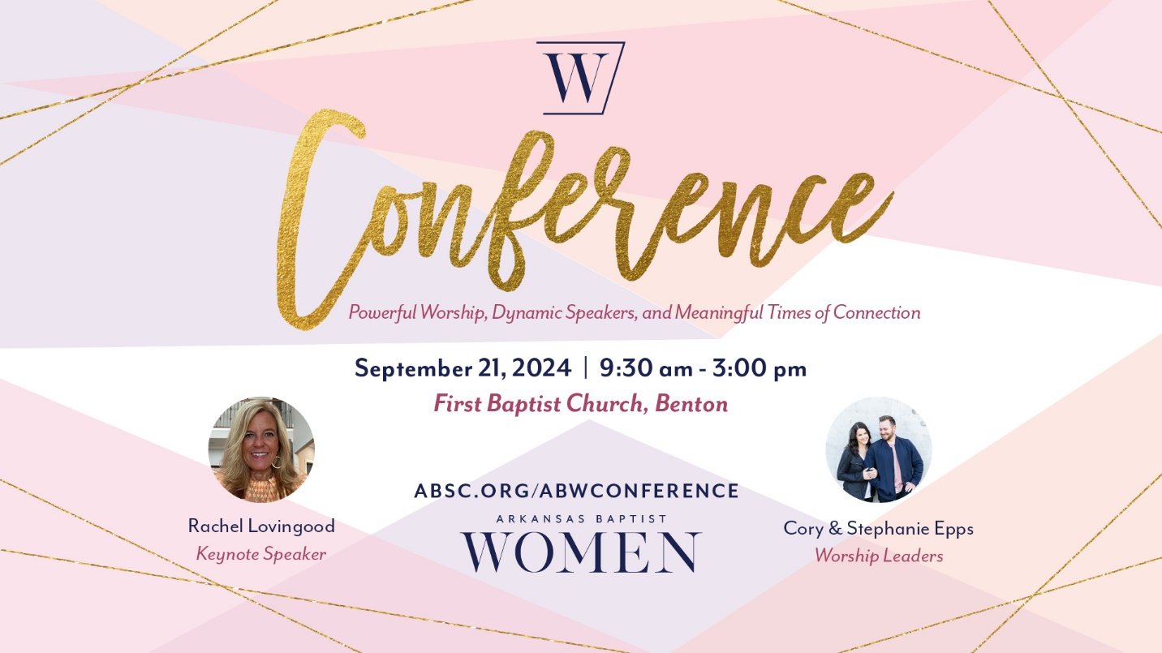

New Name - Same Great Conference!
Conference is a special day for Arkansas Baptist Women! You can expect powerful worship, dynamic speakers, and meaningful times of connection that will bless, challenge, and equip you!

This year we are asking the Lord to teach us about MORE!
- More love
- More joy
- More hope
- More peace
- More faith
- More passion
- More purpose
- We want More of Jesus!

Registration for Conference is open so invite your friends and join us on September 21, 2024, at First Baptist Church in Benton. Let’s start praying for lives that are filled with more of Jesus and less of me! Learn more and register at www.absc.org/abwconference. #arbaptistwomen #more

Conference Cost & Registration Process
Conference tickets are $35.00 for adults and $25.00 for students. Your ticket covers your conference bag, lunch, snacks, water, coffee, and tea.

The Conference registration process is easy. Log on at www.absc.org/abwconference and select individual if you are registering one person or group if you are registering several people. You will need everyone’s email address and you will need to know which Connection Group each person plans to attend. Fill out the information on the website, use a credit or debit card to pay, and you are good to go! The registration deadline is Monday, September 16th by noon or until all tickets are sold. Pray for the registration process to go smoothly and that God will bring women to Conference who need to know about God’s love, hope, and peace.

Exciting News! We are upgrading our Conference check-in process. This year you will receive an email with a QR code which will serve as your ticket to Conference. All you need to do is open the email, download your ticket, and print it off. Or you can open the email on your mobile device, download the ticket, and have the QR Code available to scan from your mobile device. YAY for no more long lines at check-in stations! Important note - you will receive the email with the QR code the week of Conference.

Powerful Worship
One thing you can count on at Conference is powerful worship. Come and enjoy worship led by Cory and Stephanie Epps. We will sing and worship together as we celebrate our freedom in and through Jesus! This year we have an exciting opportunity that will help you prepare for our special day. Cory and Stephanie have created a Spotify playlist with songs we will sing at Conference. (Link coming soon!) Please pray for Cory and Stephanie as they prepare to lead us!

Dynamic Speakers
Opening God’s Word together is one of the main reasons we gather at Conference! It’s exciting to know that the truths found in the Bible can and will change the direction of our lives. You will love our keynote speaker, Rachel Lovingood, and how she teaches the Bible. Rachel will guide us through the topic of More of Jesus. Rachel is a sweet friend to all Arkansas Baptist Women. She loves the Lord and she loves the women of Arkansas. Her teaching time will challenge and inspire us. Let’s pray for Rachel as she prepares to open God’s Word with us. Pray for clarity, focus, and anointing. May many lives be touched and changed by the challenge of more of Jesus!

Meaningful Times of Connection
Thankfully we do not have to do life on our own! Meaningful times of connection are important. This year at Conference, Connection Group time will be bigger and better than ever, with multiple groups offered. When you register for Conference, you will select the Connection Group you want to attend based on your interest or ministry role. (Please remember the Connection Group you select. Your Conference bag will coordinate with the Connection Group you select!) Then, at Conference, you will gather with your group to talk about more of Jesus and less of me. Imagine leaving Conference with friendships with other women from across Arkansas! Please pray for spiritual awakening among women and for renewed spiritual hunger. Pray for women to develop friendships with one another that will last.

Connection Groups are listed below. If you are not sure which Connection Group to select, please choose Conference Connection Group.
• Conference Connection Group: Designed for Conference participants excited to connect with other Arkansas Baptist Women. Enjoy meaningful times of conversation about more of Jesus! (This is the default Connection Group option at Conference.)
• WMU Missions Celebration: Designed for all women interested in celebrating missions and becoming more involved in making disciples of Jesus who live on mission. This is the annual meeting of Arkansas Woman's Missionary Union.
• Ministers’ Wives & Church Planting Wives Connection Group: Designed to create a safe place for all ministers’ wives to enjoy a special time of connection as you discuss the challenges and opportunities in your unique role.
• Student Connection Group: Designed to explore the unique opportunities students face in life, this connection group is for all High School students.
• Arkansas Baptist Women in Leadership Networking Group: Designed to offer a time of networking and connection for women serving in local church leadership. (Women’s Ministry team leader, Women’s Ministry Team members, Bible Study Leaders, Service Project Leaders, etc.)

Theme: More of Jesus!
What does it mean to have more of Jesus and less of me? One thing it means is that Jesus is at the center of our lives. He is our focus, and He is our desire. This leads us to understand that our lives are SO MUCH BETTER when we are pursuing Jesus. John 3:30 says, “He must increase, but I must decrease.”

Please pray for the women attending Conference to identify the areas of life holding them back. Pray for spiritual breakthroughs and spiritual progress.

Conference Merchandise
Eek! We are so excited about this year’s Conference merchandise! Fun update- you can purchase Conference merchandise on the website before the event! Click on the Conference Boutique link and start shopping. You will pick up your order at the Merchandise table at Conference. Want to wait and purchase the day of the event? No problem! We will have limited quantities available at Conference. (First come first served.)

We are excited to offer two lines of clothing. The first line features the “More of Jesus” theme. The second line features “Arkansas Baptist Women.” Pick your favorite and enjoy quality merchandise that shares the message of Jesus and represents the work of Arkansas Baptist Women.

Invite your friends to Conference!
Can you say, “Girls’ Trip!”? Just think about women from every corner of Arkansas coming together to encounter God’s love and hope. We host Conference because we want women to know God and make Him known. Conference offers a perfect opportunity to invite your friends, especially if they do not have a relationship with Jesus or are not connected to a local church. Plan a fun weekend or day trip and enjoy a special girls’ trip together! Pray that women would come to saving faith in Christ at Conference. Pray for women to get connected to a local church. Pray for women to take the next step of obedience and faith. God is so faithful to move in our lives in powerful ways.

Lifeway Bookstore
We love shopping and connecting with a purpose. This year at Conference we are excited to welcome Lifeway to our vendor area. You will LOVE all the products- books, Bibles, devotions, studies, and fun merchandise- all will be waiting for you to shop and enjoy!

Ministry Project Feature
One of the best parts of Conference is featuring a ministry project that impacts lives right here in Arkansas. This year Conference is partnering with Arkansas Baptist Children & Family Ministries and the Toy Express! That is right. We have a chance to donate toys to children in need. Please bring a new toy and donate it at the Toy Express Bus that will be parked in front of the church at Conference. For a complete list of needed items, please visit www.absc.org/abwconference and click on Ministry Project.
One story that warms our hearts from the Toy Express happened in the Jonesboro area. A Connected Foster Care & Adoption Caseworker picked up a toy from the Toy Bus and gave it to a young girl in her care on her fourth birthday. The sweet girl smiled from ear to ear and said, “I love MY baby!” Please pray for the vital work of Arkansas Baptist Children and Family Ministry. Be sure and stop by the ABCFM table in the vendor area at Conference to learn more about their vital work.
What do I need to know on the day of Conference?
Sweet Friends, we are better together! At Conference, we will welcome women from across Arkansas. The day will kick off with a party in the parking lot. We are excited to welcome everyone in a BIG and FUN way. Be sure and bring your ministry project donation for the Toy Express bus! Doors open at 8:30 a.m. and the conference begins at 9:30 a.m. This year you will scan your QR Code at the door to enter the church. (The QR Code will be sent to your email the week of Conference.) You will pick up your Conference bag that will coordinate with the Connection Group you selected. So arrive in plenty of time to check-in at the door, pick up your conference bag, shop in the vendor area, take a few pictures at the photo booth, and grab a cup of coffee and a muffin. We will see you on Saturday, September 21st, at First Baptist Church, Benton! Pray for God to be exalted as we sing, open God’s Word, and share time together. Pray that many lives are impacted by the gospel. “Lord, teach us about more of Jesus!” #arbaptistwomen #more

